How would you like a chance to win a $100 AMAZON Gift Certificate?
What are the Children’s and Teens’ Galleries?  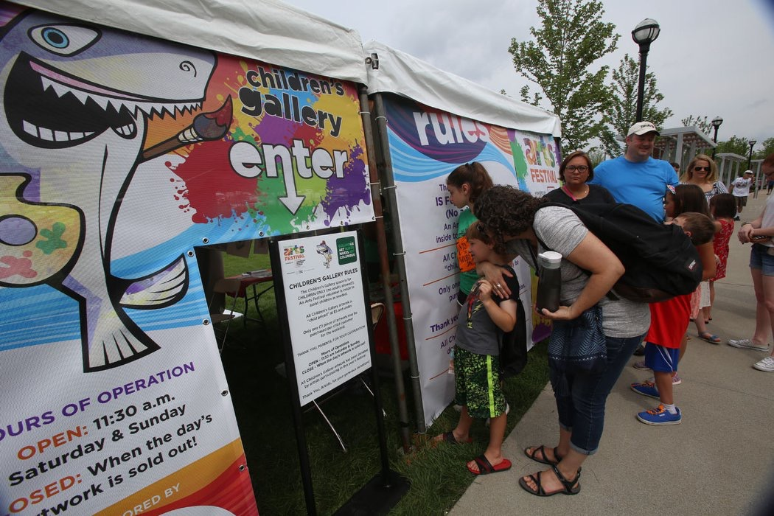 | An absolute MUST for kids on Saturday & Sunday. Children ages 12 and younger are invited to experience our unique kid-sized gallery with artwork donated by exhibiting artists.  The CAF Children’s Gallery is a long-standing tradition. Our Team collects available artwork to sell in the Galleries. Kids line-up with their grownup to wait in line to purchase YOUR work of ART.  Art is priced $5 and under per item so kids feel like art collectors too.
Teen Art Gallery | As our young art collectors grow, we want to offer an art experience that grows with them. Teens’ Gallery is exclusively for Ages 13-17.
Why you the artists are 100% of the Gallery success. | Artists donate items to help the budding art collectors start their art collection. Without your donations, there would be no Gallery. Participation is optional.
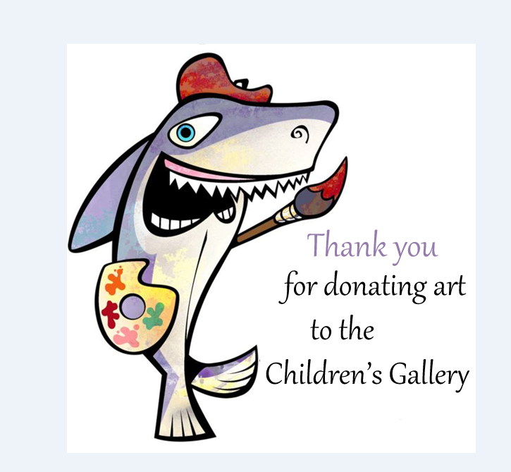  Location | Location: Dorrian Green Park in the Kids Hands On Activities Village  Children’s and Teens’ Galleries Hours:  Saturday, June 8th and Sunday, June 9th  11:00am - 2:00pm (or till sold out for the day)
Tax Deduction | The kid’s dollars support art initiatives through the Greater Columbus Arts Council.  And your donation is tax deductible.
Enter on Thursday June 6th | Drop off your art by 6:00pm at the Artist Market Check-in tent to be entered in the raffle.
Friday, June 7th | Art Collection continues with a parade of kid collectors in a golf cart escort by our volunteers on Friday. The kid collectors will stop at each booth kindly asking for donations.

