STAYING IN COMPLIANCE June 7-9, 2024
Questions?
During the festival, you can call our Artist Customer Service Phone at 380-234-9771 and ask for Lance or Patty to return your call.

Be considerate of your neighbors | Each booth space will be 10 feet by 10 feet. Set-up dimensions must be maintained to provide adequate clearance between booths. Be very aware of your neighbors and traffic paths to not create any unnecessary barriers for patrons. You will be asked to move items that disrupt foot traffic flow.
Does CAF review artist booths all 3 days of the festival? | Yes, CAF compliance is in full force all 3 days of the festival. The Artist Market Team is responsible for full inspection of booths and ensure adherence to rules and standards set forth in the prospectus.
iPad Usage | Artist Market will be carrying iPads with ZAPP photos and ask questions as needed.
Do you permit the selling of promotional items? | No. The sale of promotional items is prohibited. Examples include, but are not limited to: note cards, cards, postcards, cell phone holders, posters, how to books, books, calendars, t-shirts, mouse pads, etc. or photocopies of any kind.  You will be asked to remove these items and Artist Compliance will remain diligent checking they remain removed from your booth.
Artwork not created by the person in the booth…..can I report it?  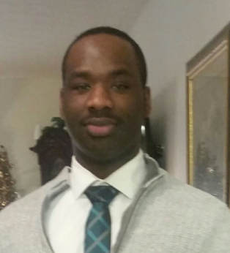  Lance Mitchell  Artist Compliance Lead | Report it. Individuals selling work that is not their own, or otherwise misrepresenting their product or themselves, are not permitted at the Columbus Arts Festival. No mass production work is permitted.  Lance Mitchell: CAF Artist Compliance Lead  Patty Matthews: Chair of CAF Artist Market  Alexis Perrone: CAF Festival Director  Your options to report:  - Call our Artist Customer Service Phone  - Walk over to our Headquarters and ask for Lance or Patty  - Stop Lance or Patty as you see them on the grounds!  REMINDER! All work must be designed and executed by the accepted artist(s).  Artists out of compliance will be asked to remove unacceptable items or risk forfeiture as an exhibitor. This includes closure of their booth for the rest of the festival with no refund.

